Name _____________________ Period________________ Corrected by _____________________ Score____________

**Background**: Although Alfred Wegener came up with the idea that the continents move, which he called continental drift, what he may not have realize was that the entire earth’s crust (including the ocean crust) moves in various sections we now call Plates. Where two plates meet, scientists call this a plate boundary. There are different types of plate boundaries depending on how the plates move relative to each other.

**Define** each Type of Plate boundary and draw a sketch to demonstrate the movement:

1. Transform Plate boundary ____________________________________________________________________________
2. Divergent Plate Boundary _____________________________________________________________________________
3. Convergent Plate Boundary____________________________________________________________________________

Directions: 1) Color the ocean and water blue 2) Color land light BROWN 3) Cut out the Plates 4) Glue them on the paper frame 5 ) ID the Plates, Continents, Oceans (PAGE 159 in Earth Science textbook)

6) Answer Questions 7) Highlight Plate boundaries (See Final Step)

**Plates:**

1. ______________________________________________________________________________
2. ______________________________________________________________________________
3. ______________________________________________________________________________
4. ______________________________________________________________________________
5. ______________________________________________________________________________
6. ______________________________________________________________________________
7. ______________________________________________________________________________
8. ______________________________________________________________________________
9. ______________________________________________________________________________
10. ______________________________________________________________________________
11. ______________________________________________________________________________
12. ______________________________________________________________________________
13. ______________________________________________________________________________

Continents:

1. __________________________________________________________________________
2. __________________________________________________________________________
3. __________________________________________________________________________
4. __________________________________________________________________________
5. __________________________________________________________________________
6. __________________________________________________________________________
7. __________________________________________________________________________

OCEANS

1. ______________________________________________________
2. ______________________________________________________
3. ______________________________________________________

**Questions:**

1. What type of plate boundary is between the Pacific and North American Plate near California? _____________________________________________________________________

1. What continents are around the Pacific Plate? ________________________________________________
2. Explain why the South American plate and the African plate are drifting farther apart from each other? __________________________________________________________________________________________

________________________________________________________________________________________________________

1. What is causing the plates to move so that they either collide, move away from each other or slide past one another? ________________________________________________________
2. What two plates are colliding (converging) to form the Himalayas? __________________________

______________________________

**Final Step:**

1. Highlight or color the Transform boundaries YELLOW:
2. Highlight or color the Convergent plate boundaries RED
3. Highlight or color the Divergent plate boundaries GREEN

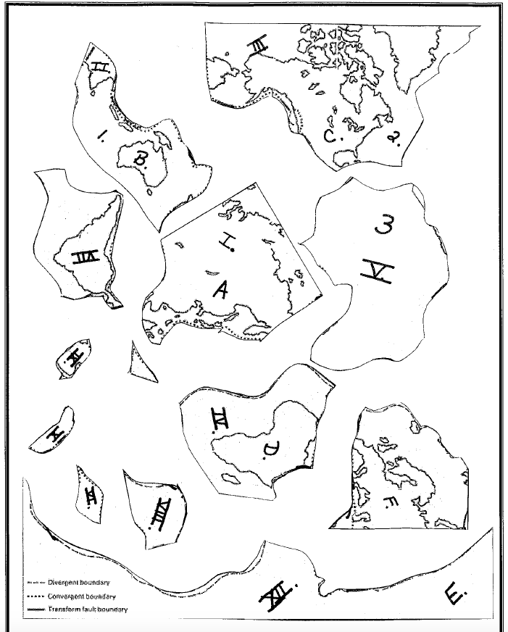

G>

XIII

XI.

XII

World View of the Plates and their Boundaries